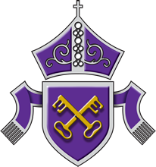
Candidate permission form - Results collection
If you are unable to attend on results day and would like to obtain your results by
one of the methods below, please tick the relevant box and complete the required information.

Uncollected results will be held securely in school until an alternative method of collection is decided upon.

Candidate name

I am unable to attend results day on ………………………………………….. and would like to receive my results by:

(please choose ONE option only)

MCAS (My Child at School)

Third party - I give permission for my representative (insert name) .................................................................. to collect the results on my behalf. I confirm that my representative will provide photographic ID on collection.

Email (insert email address) …………………………………………………….................... I understand that this may take until 5pm on results day.
Candidate signature |  | Date

Completed forms should be emailed to exams@becketkeys.org or returned to reception, FAO The Exams Officer, Miss L. Dent, at least 3 days before results are released.

